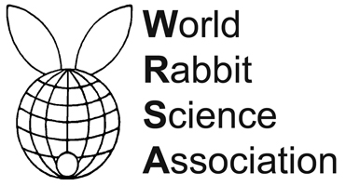
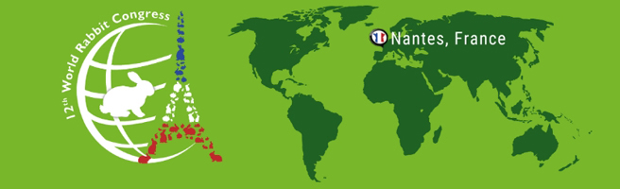

PROCEEDINGS OF THE 12th WORLD RABBIT CONGRESS
Nantes (France) - November 3-5, 2021
ISSN 2308-1910

Session
REPRODUCTION

Villamayor PR., Gullón J., Vilá M., Yáñez U., Aramburu O.,
Sánchez M., Sánchez-Quinteiro P., Martínez P., Quintela L.

PRELIMINARY REPORT OF POTENTIAL BIOSTIMULATION METHODS BASED ON CHEMICAL COMMUNICATION IN RABBIT DOE REPRODUCTION

Full text of the communication
+
Poster

How to cite this paper
Villamayor PR., Gullón J., Vilá M., Yáñez U., Aramburu O., Sánchez M., Sánchez-Quinteiro P., Martínez P., Quintela L., 2021. Preliminary report of potential biostimulation methods based on chemical communication in rabbit doe reproduction. Proceedings 12th World Rabbit Congress - November 3-5 2021 - Nantes, France, Communication R-20, 4 pp. + presentation

