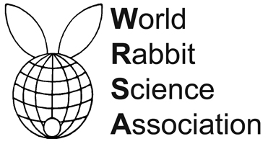
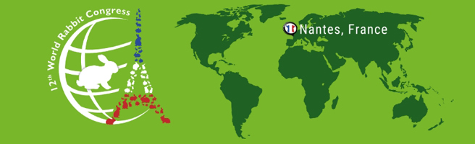

PROCEEDINGS OF THE 12th WORLD RABBIT CONGRESS
Nantes (France) - November 3-5, 2021
ISSN 2308-1910

Session
REPRODUCTION

Savietto D., Debrusse A.M., Bonnemère J.M., Labatut D., Aymard P.,
Combes S., Fortun-Lamothe L., Gunia M.

REPRODUCTIVE PERFORMANCE OF A MATERNAL RABBIT CROSS :
FAUVE-DE-BOURGOGNE × INRA-1777

Full text of the communication
+
Slides of the oral presentation

How to cite this paper
Savietto D., Debrusse A.M., Bonnemère J.M., Labatut D., Aymard P., Combes S., Fortun-Lamothe L., Gunia M., 2021. Reproductive performance of a maternal rabbit cross : Fauve-de-Bourgogne × INRA-1777. Proceedings 12th World Rabbit Congress - November 3-5 2021 - Nantes, France, Communication R-18, 4 pp. + presentation

