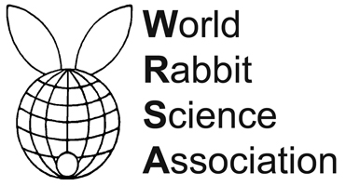
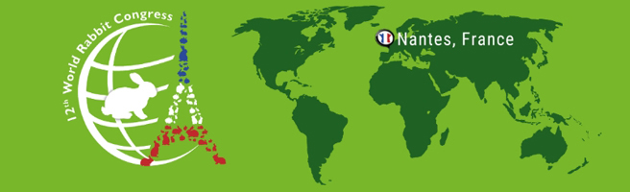

PROCEEDINGS OF THE 12th WORLD RABBIT CONGRESS
Nantes (France) - November 3-5, 2021
ISSN 2308-1910

Session
REPRODUCTION

Rouillon C., Camugli S., Carion O., Echegaray A., Delhomme G., Schmitt E.

DEVELOPMENT OF A NEW ANTIBIOTIC COMPOSITION
FOR A RABBIT SEMEN DILUTION MEDIUM (GALAP®)

Full text of the communication
+
Slides of the oral presentation

How to cite this paper
Rouillon C., Camugli S., Carion O., Echegaray A., Delhomme G., Schmitt E., 2021. Development of a new antibiotic composition for a rabbit semen dilution medium (Galap®). Proceedings 12th World Rabbit Congress - November 3-5 2021 - Nantes, France, Communication R-16, 4 pp.

