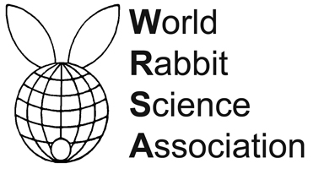
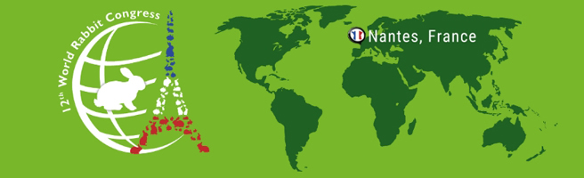

PROCEEDINGS OF THE 12th WORLD RABBIT CONGRESS
Nantes (France) - November 3-5, 2021
ISSN 2308-1910

Session
REPRODUCTION

Eiben Cs., Sándor M., Sándor F., Mohaupt M., Kustos K.

EFFECT OF SHORT FAST-REFEEDING AND LIGHT PROGRAM
ON RABBIT DOE REPRODUCTION

Full text of the communication
+
Slides of the oral presentation

How to cite this paper
Eiben Cs., Sándor M., Sándor F., Mohaupt M., Kustos K., 2021. Effect of short fast-refeeding and light program on rabbit doe reproduction. Proceedings 12th World Rabbit Congress - November 3-5 2021 - Nantes, France, Communication R-08, 4 pp. + presentation

