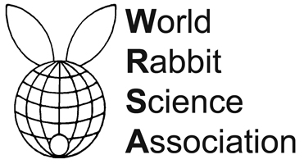


PROCEEDINGS OF THE 12th WORLD RABBIT CONGRESS
Nantes (France) - November 3-5, 2021
ISSN 2308-1910

Session
REPRODUCTION

Anoh K. U.

THE INFLUENCE OF ORGANIC AND SYNTHETIC ANTIOXIDANT
ON THE REPRODUCTIVE PERFORMANCE OF HEAT STRESSED RABBIT
UNDER TROPICAL CONDITION OF NIGERIA

Full text of the communication
+
Slides of the oral presentation

How to cite this paper
Anoh K. U., 2021. The influence of organic and synthetic antioxidant on the reproductive performance of heat stressed rabbit under tropical condition of Nigeria. Proceedings 12th World Rabbit Congress - November 3-5 2021 - Nantes, France, Communication R-02, 4 pp. + presentation

