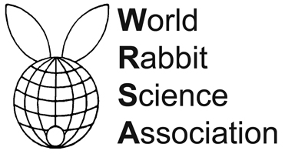


PROCEEDINGS OF THE 12th WORLD RABBIT CONGRESS
Nantes (France) - November 3-5, 2021
ISSN 2308-1910

Session
REPRODUCTION

Mattioli S., Maranesi M., Castellini C., Dal Bosco A., Arias-Alvarez M.,
Lorenzo P.L., Rebollar P.G., Garcia-Garcia R.M.

PHYSIOLOGY AND MODULATION FACTORS OF OVULATION
IN RABBIT REPRODUCTION MANAGEMENT
(invited paper)

Full text of the communication
+
Slides of the oral presentation

How to cite this paper
Mattioli S., Maranesi M., Castellini C., Dal Bosco A., Arias-Alvarez M., Lorenzo P.L., Rebollar P.G., Garcia-Garcia R.M., 2021. Physiology and modulation factors of ovulation in rabbit reproduction management (invited paper). Proceedings 12th World Rabbit Congress - November 3-5 2021 - Nantes, France, Communication R-00, 10 pp. + presentation

